SCHOOL

Year 12 Trial WACE Examination, 2013

Question/Answer Booklet

MATHEMATICS: SPECIALIST 3C/3D
If required by your examination administrator, please place your student identification label in this box

Section One:

Calculator-free

Student Number: In figures

In words

Your name

Time allowed for this section
Reading time before commencing work: five minutes
Working time for this section: fifty minutes

Materials required/recommended for this section

To be provided by the supervisor
This Question/Answer Booklet
Formula Sheet

To be provided by the candidate
Standard items: pens, pencils, pencil sharpener, eraser, correction fluid/tape, ruler, highlighters

Special items: nil

Important note to candidates

No other items may be used in this section of the examination. It is your responsibility to ensure that you do not have any unauthorised notes or other items of a non-personal nature in the examination room. If you have any unauthorised material with you, hand it to the supervisor before reading any further.

Structure of this paper

Section | Number of questions available | Number of questions to be answered | Working time (minutes) | Marks available | Percentage of exam
Section One:  Calculator-free | 7 | 7 | 50 | 50 | 33
Section Two:  Calculator-assumed | 13 | 13 | 100 | 100 | 67
 |  |  | Total | 150 | 100

Instructions to candidates

- The rules for the conduct of Western Australian external examinations are detailed in the Year 12 Information Handbook 2013. Sitting this examination implies that you agree to abide by these rules.

- Write your answers in the spaces provided in this Question/Answer Booklet. Spare pages are included at the end of this booklet. They can be used for planning your responses and/or as additional space if required to continue an answer.
- Planning: If you use the spare pages for planning, indicate this clearly at the top of the page.
- Continuing an answer: If you need to use the space to continue an answer, indicate in the original answer space where the answer is continued, i.e. give the page number. Fill in the number of the question(s) that you are continuing to answer at the top of the page.

- Show all your working clearly. Your working should be in sufficient detail to allow your answers to be checked readily and for marks to be awarded for reasoning. Incorrect answers given without supporting reasoning cannot be allocated any marks. For any question or part question worth more than two marks, valid working or justification is required to receive full marks. If you repeat an answer to any question, ensure that you cancel the answer you do not wish to have marked.

- It is recommended that you do not use pencil, except in diagrams.

Section One: Calculator-free (50 Marks)
This section has seven (7) questions. Answer all questions. Write your answers in the spaces provided.

Working time for this section is 50 minutes.

Question 1 (4 marks)
Determine the equation of the tangent to 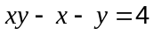 when 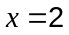.

Question 2 (6 marks)
(a) If 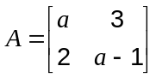 determine the value(s) of such that 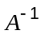 is singular. (2 marks)

(b) Solve the equation 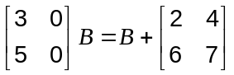 for the 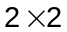 matrix . (4 marks)

Question 3 (4 marks)
A floating pontoon at a tidal marina is connected to the top of the harbour wall by a hinged walkway AB of length 13 metres.
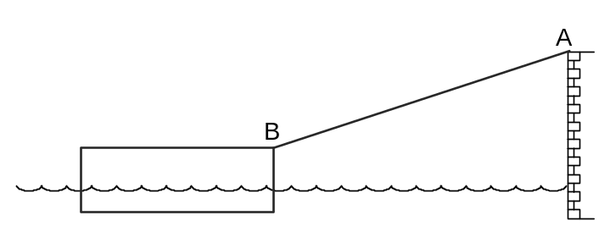
When the top of the pontoon, B, is 5 m below the top of the wall, A, the sea is rising at a rate of 2 cm per minute.

At this instant, calculate the rate at which the barge is moving away from the wall.

Question 4 (9 marks)
The complex number 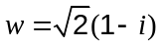.

(a) Use de Moivre's theorem to show that for any integer , 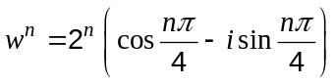.
(3 marks)

(b) Determine the smallest positive integer for which 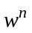 is real and positive. (2 marks)

(c) Given that is a root of the equation 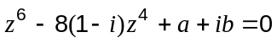, find the values of the real constants and . (4 marks)

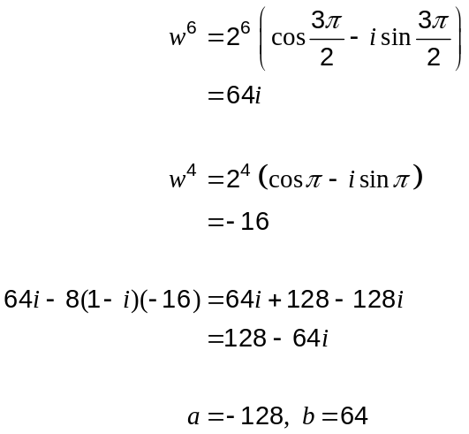

Question 5 (8 marks)
(a) Solve the equation 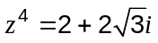, expressing all solutions in polar form. (4 marks)

(b) One solution to the equation 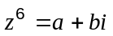, where and are real constants, is shown on the diagram below.
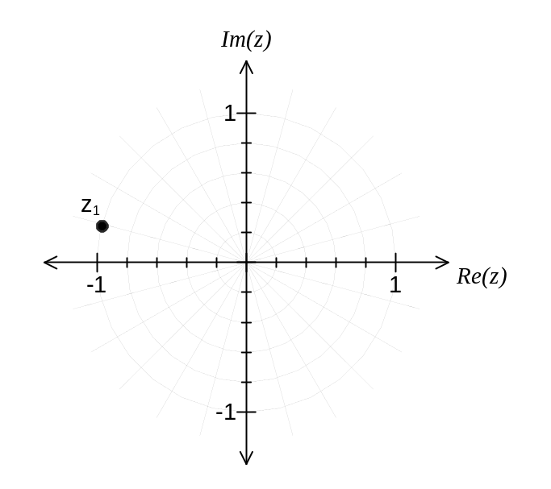
(i) Plot all other solutions to the equation on the diagram. (2 marks)

(ii) Determine the values of and . (2 marks)

Question 6 (7 marks)
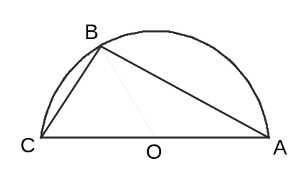(a) Thales's theorem states that an inscribed angle in a semi-circle is a right angle.

Letting 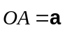 and 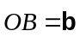, or otherwise, use a vector method to prove Thales's theorem.

(3 marks)

(b) The angle between the vectors 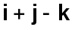 and 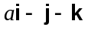 is 120°. Find the value of .
(4 marks)

Question 7 (12 marks)
The function 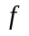 is defined as 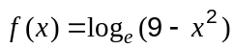.

(a) State the natural domain of . (1 mark)

(b) Sketch the graph of on the axes below, labelling all key features. (3 marks)
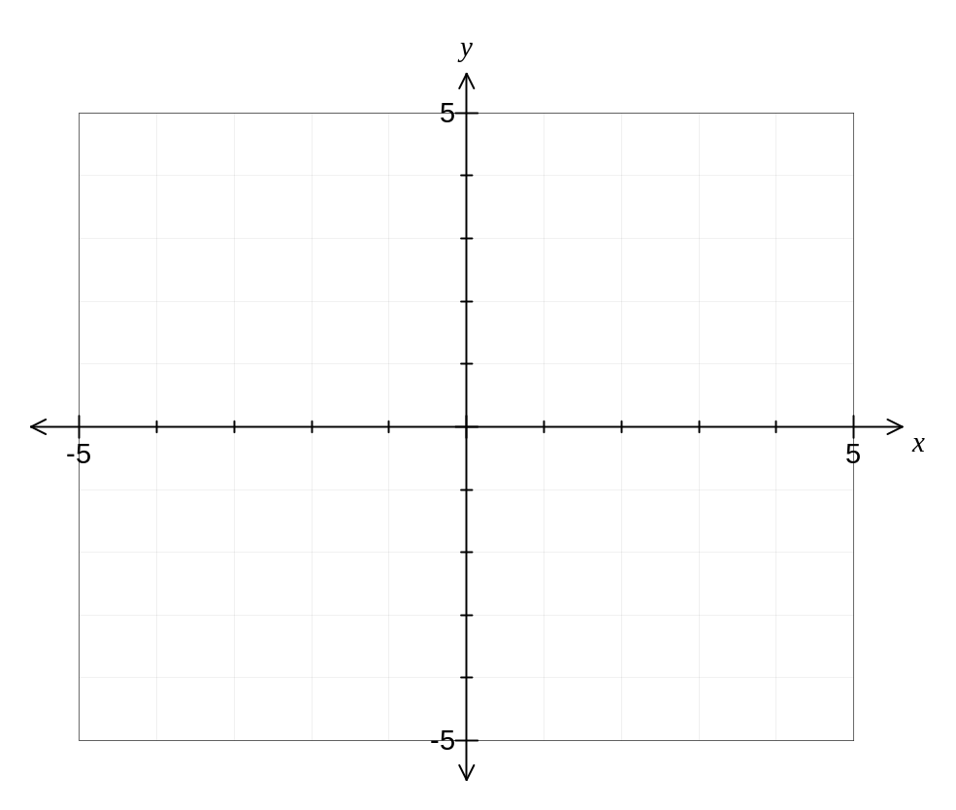

(c) Differentiate 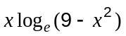. (2 marks)

(d) Show that 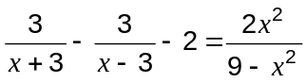. (2 marks)

(e) Determine the area enclosed by the graph of , the coordinate axes and the line in the form 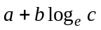, where , and are integers. (4 marks)

This examination paper may be freely copied, or communicated on an intranet, for non-commercial purposes within educational institutes that have purchased the paper from WA Examination Papers provided that WA Examination Papers is acknowledged as the copyright owner. Teachers within purchasing schools may change the paper provided that WA Examination Paper's moral rights are not infringed.

Copying or communication for any other purposes can only be done within the terms of the Copyright Act or with prior written permission of WA Examination papers.

Published by WA Examination Papers
PO Box 445 Claremont WA 6910

